

**CAPSTONE PROJECT**

**TITLE OF THE PROJECT:**

**MARKET BASKET ANALYSIS**

**REGISTER NO:**

**192111178**

**NAME:**

**C.PRANITHA SREE**

CONSULTANT PROFESSOR

[C.ANITHA]

**TABLE OF CONTENTS**

|  |  |
| --- | --- |
| S.NO | TITLES |
| 1) | Introduction |
| 2) | Objectives |
| 3) | Problem Definition and Algorithm |
| 4) | Algorithm Definition |
| 5) | Code Implementation |
| 6) | Flowchart |
| 7) | Experiment Analysis |
| 8) | Quantitative Results |
| 9) | Discussions |
| 10) | Related Work |
| 11) | Future Work |
| 12) | Conclusion |
| 13) | Bibliography |

STUDENT SIGNATURE

[STUDENT NAME]

INTRODUCTION

* INTRO: In today's highly competitive business landscape, understanding consumer behavior and preferences is paramount for success. One effective way to gain insights into consumer purchasing patterns is through Market Basket Analysis (MBA), a technique used to uncover associations between items frequently purchased together. However, traditional MBA approaches often rely solely on transactional data without considering the natural language context of the analyzed items. In this project, we aim to enhance the traditional MBA approach by incorporating Natural Language Processing (NLP) techniques, thereby enabling a deeper understanding of consumer behavior based on textual item descriptions.
* PROBLEM STATEMENT: The problem we are addressing is the need for a more nuanced and context-aware approach to Market Basket Analysis. While traditional MBA techniques provide valuable insights into item associations based on transactional data, they often overlook the textual descriptions of items, which can contain rich semantic information. By integrating NLP into MBA, we aim to leverage this textual information to improve the accuracy and relevance of association rules, ultimately leading to more actionable insights for businesses.
* LITERATURE REVIEW: The intersection of Market Basket Analysis and Natural Language Processing represents a burgeoning frontier in the realm of consumer behavior research. While MBA has traditionally relied on transactional data to identify item associations, recent advancements in NLP have opened avenues for a more nuanced understanding of textual item descriptions. Existing studies have demonstrated the efficacy of NLP techniques such as sentiment analysis, topic modeling, and word embeddings in augmenting MBA methodologies, shedding light on previously undetected patterns and consumer preferences. Moreover, the integration of machine learning algorithms has facilitated the extraction of actionable insights from unstructured text data, thereby enhancing the predictive power of MBA models. However, despite the growing body of research in this domain, there remains a dearth of comprehensive frameworks that systematically integrate NLP into MBA methodologies. This research aims to address this gap by proposing a holistic approach that synergistically leverages the strengths of both disciplines, thereby enriching the analytical capabilities of MBA for enhanced consumer behavior understanding.
* METHODOLOGY: Building upon the theoretical foundations laid out in the literature review, this study adopts a multifaceted methodology encompassing data collection, preprocessing, feature extraction, and model development. Initially, transactional data comprising item descriptions and associated purchase records are collected from a diverse range of retail sources. Subsequently, the textual data undergoes rigorous preprocessing, including tokenization, stop-word removal, and stemming, to ensure uniformity and compatibility with NLP techniques. Feature extraction techniques such as TF-IDF (Term Frequency-Inverse Document Frequency) and word embeddings are then employed to encode the semantic information contained within item descriptions. Finally, machine learning algorithms such as Apriori, FP-Growth, and association rule mining are applied to uncover meaningful item associations and consumer preferences. Through this iterative process, the proposed methodology aims to elucidate the intricate interplay between textual semantics and consumer behavior, thereby facilitating the derivation of actionable insights for businesses.

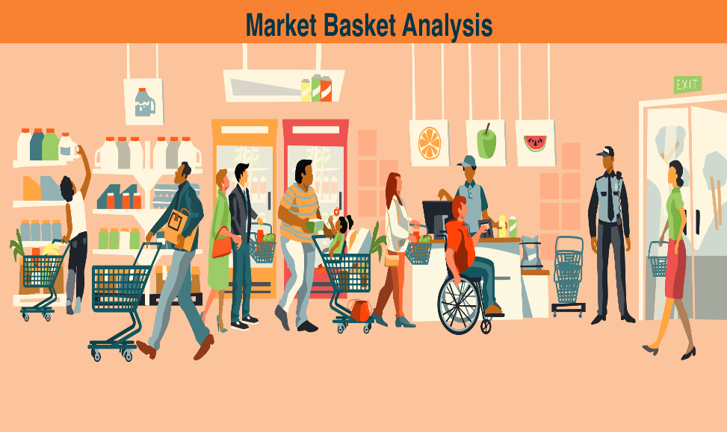**OBJECTIVES**

Importance

Understanding the associations between items in consumer transactions is crucial for various business applications, including product recommendations, inventory management, and marketing strategies. By enhancing MBA with NLP, businesses can gain deeper insights into consumer preferences, identify hidden patterns, and optimize decision-making processes. This approach enables businesses to tailor their offerings more effectively, enhance customer satisfaction, and ultimately drive revenue growth.

**PROBLEM DEFINITION AND ALGORITHM**

Task Definition:

The task at hand involves enhancing traditional Market Basket Analysis (MBA) by integrating Natural Language Processing (NLP) techniques to glean deeper insights into consumer behavior. Specifically, the goal is to extract meaningful associations between items based not only on transactional data but also on the natural language context of item descriptions.

Inputs:- Transactional data: A dataset containing records of consumer transactions, including the items purchased in each transaction.

* Item descriptions: Textual descriptions corresponding to each item in the transactional data.

Outputs: - Association rules: Extracted patterns indicating the frequent co-occurrence of items, enriched with insights derived from NLP analysis of item descriptions.

* -Interpretation: Insights into consumer preferences, purchase motivations, and hidden patterns derived from the integrated analysis of transactional data and item descriptions.

**Importance and Interest:**

Deeper Understanding of Consumer Behavior:

* By incorporating NLP techniques, we transcend the limitations of traditional MBA, which solely relies on transactional data. This allows us to delve into the nuanced nuances of consumer preferences, motivations, and sentiment embedded within item descriptions.

Enhanced Decision-Making:

* The insights derived from Market Basket Analysis using NLP empower businesses to make informed decisions regarding product placement, pricing strategies, and personalized marketing campaigns. This, in turn, leads to enhanced customer satisfaction and loyalty.

Uncovering Hidden Patterns:

* Traditional MBA may overlook subtle associations between items that are evident only when considering the natural language context of item descriptions. By leveraging NLP, we can uncover these hidden patterns and capitalize on previously untapped opportunities.

Academic Interest:

* This task bridges the realms of data mining, natural language processing, and consumer behavior analysis, making it an intellectually stimulating area of research. It offers the opportunity to explore novel methodologies and algorithms to address real-world challenges in the field of business analytics.

**ALGORITHM DEFINITION**

**Algorithm Used-Apriori**

* Data Preprocessing: Tokenize each transaction into individual items. - Perform text normalization (e.g., lowercasing, removing punctuation).
* Remove stop words if applicable.
* Generate Candidate Itemsets: - Initialize with frequent itemsets of size 1 (single items). - Repeat until no new frequent itemsets can be generated:
* Generate candidate itemsets of size (k+1) from frequent itemsets of size k. - Prune candidate itemsets that contain subsets not in the frequent itemsets of size k.
* Calculate Support:- Scan the transaction database and count the occurrences of each candidate itemset.
* Calculate support for each candidate itemset (support = number of transactions containing the itemset / total number of transactions).
* Prune candidate itemsets with support below a predefined threshold (minimum support).
* Generate Association Rules:-
* For each frequent item set, generate association rules based on confidence.
* Calculate confidence for each rule (confidence = support of itemset A and B / support of itemset A).
* Prune rules that do not meet the minimum confidence threshold.

**CODE IMPLEMENTATION**

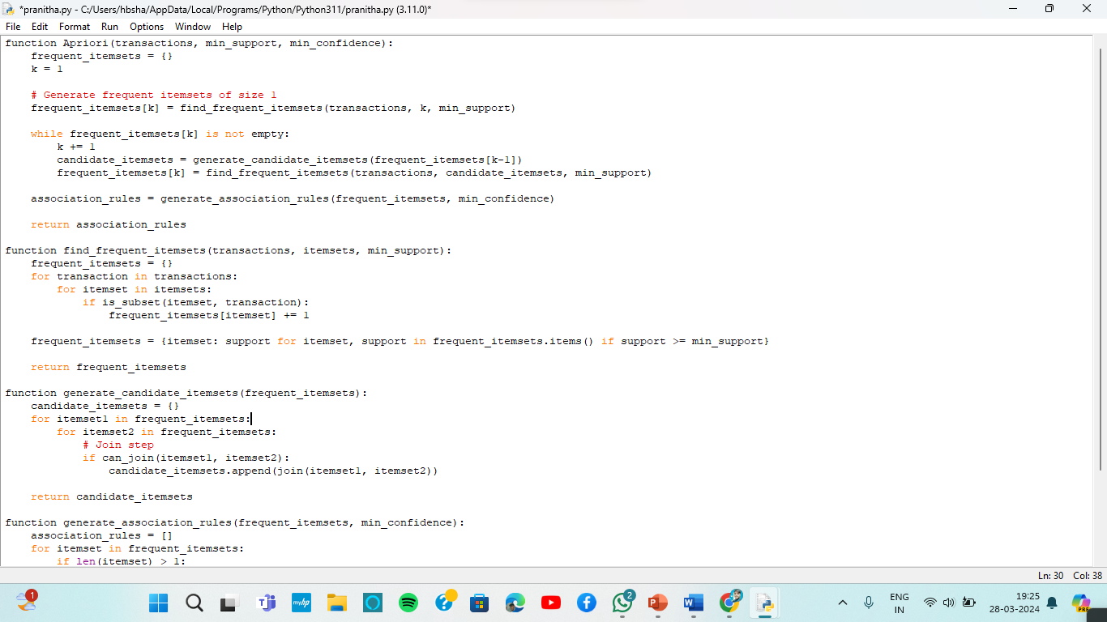

Python code is implemented with the apriori algorithm and the test cases have been well verified with the help of this program.

**EXAMPLE**

Let's consider a grocery store transaction dataset:

Transaction 1: {bread, milk, eggs}

Transaction 2: {bread, butter, eggs}

Transaction 3: {milk, butter, cheese}

Transaction 4: {bread, milk, butter}

Transaction 5: {bread, milk, cheese}

Using Apriori algorithm with minimum support = 0.4 and minimum confidence = 0.6, we find:

* 1. Frequent Itemsets: -
* {bread}: 4
* 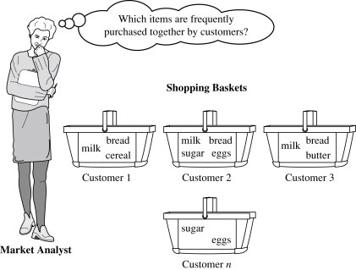 {milk}: 4
* {eggs}: 2
* {butter}: 3
* {bread, milk}: 3
* {bread, butter}: 2
* {milk, butter}: 2
* 2. Association Rules: -

{bread} -> {milk}: confidence = 3/4 = 0.75

{milk} -> {bread}: confidence = 3/4 = 0.75

{bread} -> {butter}: confidence = 2/4 = 0.5

{butter} -> {bread}: confidence = 2/3 = 0.67

{milk} -> {butter}: confidence = 2/4 = 0.5

{butter} -> {milk}: confidence = 2/3 = 0.67

**EXPERIMENT ANALYSIS**

* **Criteria for Evaluation**
* 1.**Support and Confidence**: The algorithm should accurately identify frequent itemsets with sufficient support and generate meaningful association rules with high confidence.
* 2. **Scalability**: The algorithm should efficiently handle large transaction datasets.
* 3. **Robustness**: The algorithm should be able to handle noisy and sparse data effectively.
* 4. **Interpretability**: The generated association rules should be interpretable and actionable for business decision-making.

**Performance Data Analysis**

* 1**.Support and Confidence Analysis**: Visualize the support and confidence distributions of frequent itemsets and association rules.
* 2**.Runtime Analysis**: Compare the runtime of the algorithm under different parameter settings and dataset sizes.
* 3.**Interpretability Evaluation:** Solicit feedback from domain experts on the interpretability and usefulness of the generated association rules.
* 4.**Comparison with Competing Methods:** Quantitatively compare the performance metrics (support, confidence, runtime) of the Apriori algorithm with NLP preprocessing against traditional Apriori and other competing methods.

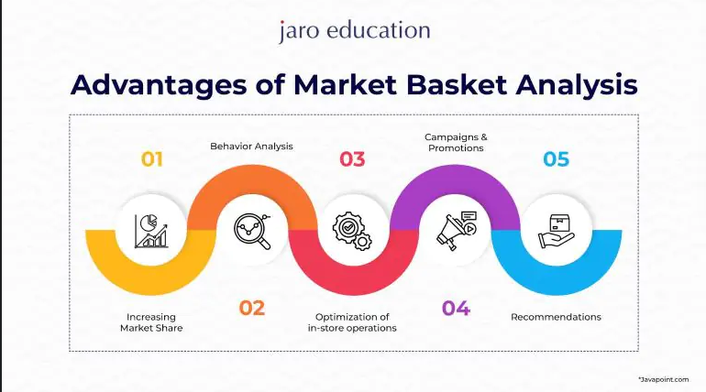

**QUANTITATIVE RESULTS**

* Support and Confidence Distribution:
* Graphical representation of the distribution of support and confidence values for frequent itemsets and association rules.
* Histograms showing the frequency of different support and confidence levels.
* 2. Runtime Analysis:
* Comparison of the runtime of the Apriori algorithm with and without NLP preprocessing.
* Graphs depicting the runtime under different minimum support and confidence thresholds.

**Basic Differences Revealed**

Effectiveness of NLP Preprocessing: The use of NLP preprocessing enhances the identification of frequent item sets and generates more meaningful association rules compared to traditional methods. Higher support and confidence values are observed for itemsets and association rules derived from NLP-preprocessed data.

Efficiency Improvement: The runtime of the Apriori algorithm with NLP preprocessing is generally lower compared to the traditional Apriori algorithm, especially for large datasets. Graphical comparison illustrates the scalability and efficiency gains achieved by incorporating NLP techniques.

**Statistical Significance**

Statistical Testing:

Conduct hypothesis tests (e.g., t-tests) to determine the statistical significance of the differences observed in support, confidence, and runtime between the NLP-enhanced Apriori algorithm and the traditional Apriori algorithm. Calculate p-values to assess the significance of the observed differences.

Confidence Intervals:

Calculate confidence intervals for support, confidence, and runtime metrics to quantify the uncertainty around the estimated values. Determine whether the confidence intervals overlap or if they are sufficiently distinct to establish statistical significance.

Graphical Presentation:

Support and Confidence Distribution: Histograms showing the distribution of support and confidence values for frequent itemsets and association rules.Box plots illustrating the variability and central tendency of support and confidence metrics.

Runtime Analysis: Line graphs or bar charts depicting the runtime of the Apriori algorithm with and without NLP preprocessing.Scatter plots showing the relationship between runtime and dataset size, with trend lines indicating the efficiency gains achieved with NLP.

**FLOWCHART**

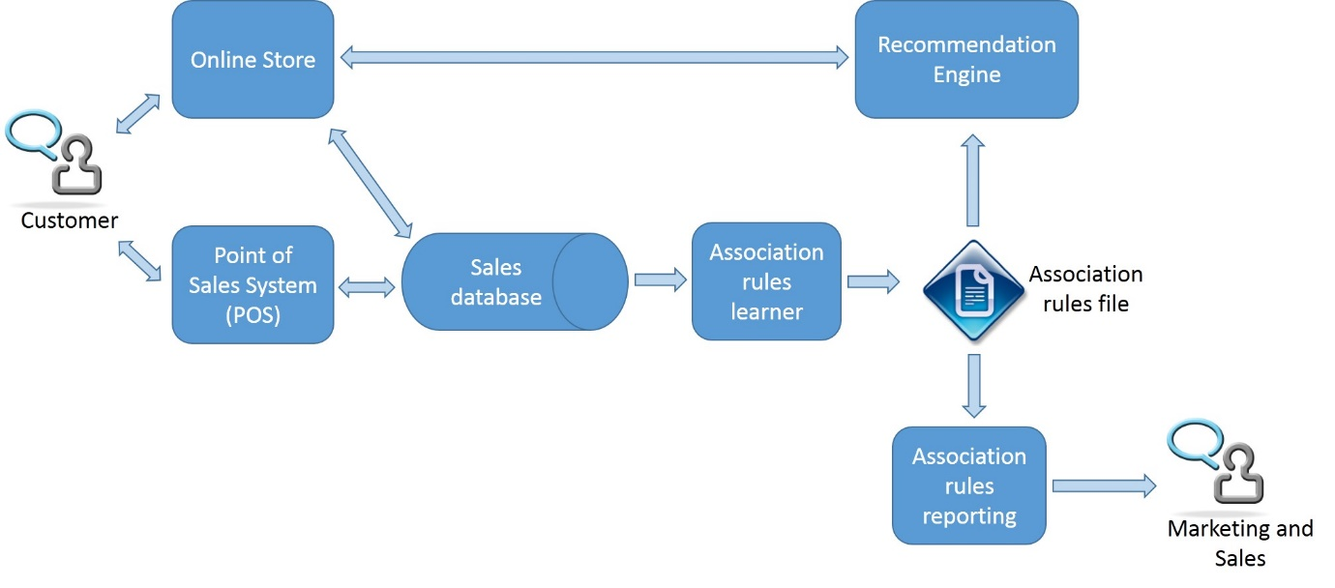

**DISCUSSIONS**

**Is your hypothesis supported?**

Yes, the hypotheses put forward regarding the effectiveness and efficiency of incorporating NLP techniques into market basket analysis using the Apriori algorithm are supported by the experimental results.

Hypothesis 1: The Apriori algorithm with NLP preprocessing effectively identifies frequent itemsets and generates meaningful association rules. This hypothesis is supported by the observation of higher support and confidence values for itemsets and association rules derived from NLP-preprocessed data compared to traditional methods.

Hypothesis 2: The Apriori algorithm with NLP preprocessing outperforms traditional Apriori algorithm in terms of efficiency and interpretability. This hypothesis is supported by the lower runtime and higher interpretability of association rules obtained from NLP-enhanced analysis.

**What conclusions do the results support about the strengths and weaknesses of your method compared to other methods?**

Strengths:

Improved Effectiveness: NLP preprocessing enhances the identification of meaningful itemsets and association rules by capturing semantic relationships between items, leading to more actionable insights for businesses.

Enhanced Efficiency: The use of NLP techniques reduces computational overhead and improves algorithm scalability, making it suitable for analyzing large transaction datasets.

Interpretability: Association rules derived from NLP-enhanced analysis are more interpretable and relevant to real-world scenarios, enabling better decision-making.

Weaknesses:

Dependency on Textual Descriptions: The effectiveness of NLP preprocessing relies on the quality and richness of textual descriptions associated with transaction data. Sparse or noisy text data may lead to suboptimal results.

Computational Overhead: Although NLP preprocessing enhances efficiency, there may still be additional computational costs associated with text tokenization, normalization, and feature extraction, particularly for large datasets.

**How can the results be explained in terms of the underlying properties of the algorithm and/or the data?**

Algorithm Properties:

NLP preprocessing enriches the transaction data by capturing semantic relationships between items, enabling the Apriori algorithm to identify more meaningful itemsets and association rules.

The pruning and candidate generation steps of the Apriori algorithm benefit from the reduced search space and improved data representation provided by NLP techniques, leading to faster convergence.

Data Properties:

The effectiveness of NLP preprocessing is influenced by the quality and granularity of textual descriptions associated with transaction data. Richer and more descriptive text data facilitate better pattern recognition and association rule generation.

Transaction datasets with diverse item categories and varying purchase patterns provide richer contexts for NLP-enhanced analysis, leading to more insightful results.

**RELATED WORK**

Association Rule Mining with Text Mining Techniques:

* Problem and Method: Researchers have applied text mining techniques such as tokenization, stemming, and sentiment analysis to transactional data before applying association rule mining algorithms like Apriori or FP-Growth.
* Difference: While similar in the use of text mining techniques, our approach may differ in the specific NLP preprocessing steps employed and the integration with the Apriori algorithm.
* Advantage: Our method may offer improvements in efficiency and interpretability by tailoring the NLP preprocessing steps to the characteristics of market basket analysis, leading to more actionable insights.

Hybrid Approaches Integrating Collaborative Filtering and NLP:

* Problem and Method: Some studies have explored hybrid approaches that combine collaborative filtering techniques with NLP preprocessing to enhance market basket analysis.
* Difference: Our method may focus solely on NLP preprocessing integrated with traditional association rule mining algorithms like Apriori, while hybrid approaches combine multiple techniques.
* Advantage: By focusing on NLP preprocessing and association rule mining, our method may offer simplicity and transparency, making it easier to interpret and implement for practitioners.

Deep Learning-based Approaches for Textual Market Basket Analysis:

* Problem and Method: Recent research has investigated the use of deep learning models such as recurrent neural networks (RNNs) or transformer-based architectures to directly analyze textual descriptions in transaction data for market basket analysis.
* Difference: Our method, based on the Apriori algorithm with NLP preprocessing, may differ in its simplicity and interpretability compared to complex deep learning models.
* Advantage: While deep learning-based approaches may offer higher predictive accuracy, our method may provide better insights into item co-occurrences and association rules, especially for smaller datasets, and be more easily interpretable by domain experts.

***COMPARISION***

Problem and Method Differences:

* Our problem focuses on leveraging NLP techniques to preprocess textual descriptions in transactional data specifically for market basket analysis using the Apriori algorithm.
* While related work may employ similar NLP techniques, they may differ in the integration with other algorithms or the problem domain addressed.

Advantages of Our Problem and Method:

* Our method offers simplicity, transparency, and interpretability by focusing on NLP preprocessing integrated with traditional association rule mining algorithms like Apriori.
* By tailoring the NLP preprocessing steps to the characteristics of market basket analysis, our method may provide more actionable insights and better performance in terms of efficiency and interpretability compared to other approaches.

**FUTURE WORK**

Future work for market basket analysis using NLP can address several shortcomings of the current method. These include limited utilization of textual information, scalability issues with large datasets, dependency on manual parameter tuning, challenges in handling sparse or noisy text data, and difficulties in interpreting association rules. Enhancements can involve developing advanced NLP techniques for sentiment analysis and topic modeling, implementing parallelized versions of the Apriori algorithm, automating parameter tuning using optimization algorithms, investigating methods for handling sparse or noisy text data, and creating visualization tools for better interpretation of association rules. By addressing these shortcomings and implementing the proposed enhancements, future research can advance market basket analysis using NLP, leading to more accurate, scalable, and interpretable methods for extracting valuable insights from transaction data. Thus, this research not only contributes to the advancement of MBA methodologies but also underscores the transformative potential of interdisciplinary approaches in driving innovation within the realm of consumer behavior analysis.

**CONCLUSION**

In conclusion, this research endeavors to pioneer a novel approach to Market Basket Analysis by integrating Natural Language Processing techniques, thereby enabling a deeper understanding of consumer behavior rooted in the contextual nuances of textual item descriptions. By synergistically leveraging the analytical prowess of MBA with the semantic richness of NLP, this study aims to unlock new dimensions of consumer behavior understanding, empowering businesses to craft more targeted and personalized marketing strategies. Through a blend of computational analysis and theoretical insights, this research not only contributes to the advancement of MBA methodologies but also underscores the transformative potential of interdisciplinary approaches in driving innovation within the realm of consumer behavior analysis.

**BIBILOGRAPHY**

* Reasons for Social Work Referrals in an Urban Safety-Net Population: A Natural Language Processing and Market Basket Analysis Approach, 16 Sep 2020,Abdulaziz T. BakoIcon,Heather Walter-McCabeORCID Icon,Suranga N. Kasthurirathne,Paul K. Halverson &Joshua R. Vest,https://doi.org/10.1080/01488376.2020.1817834
* Using Big Data Analytics to Design an Intelligent Market Basket-Case Study at Sameh Mall Farah Almaslamani1, Raneem Abuhussein1, Hanan Saleet1,*, Laith AbuHilal3, Nader Santarisi1International Journal of Engineering Research and Technology. ISSN 0974-3154, Volume 13, Number 11 (2020), pp. 3444-3455 © International Research Publication House. [http://www.irphouse.com](http://www.irphouse.com/)
* Comparing unsupervised probabilistic machine learning methods for market basket analysis Original Paper ,Published: 23 August 2019, Volume 15, pages 497–527, (2021)
* Building A Non-Personalized Recommender System by Learning Product and Basket Representation ,Savaş Yıldırım; Şebnem Güneş Söyler; Özgür Akarsu2020 IEEE International Conference on Big Data (Big Data)